**Brand “BMW”**

**Paid media:**

* TV ads - for products like cars it’s easy to show new features in video format and it helps potential customers visualize themselves in the ad.
* BMW magazines and catalogs - pictures can easily show new features and easy to list them as bullet points, since the readers already know that the product is a car, no need to introduce that
* Social media ads - videos on youtube, instagram, meta and other platform ads. They choose completely different ad creatives for different platforms, of course the research has been done of what’s working on each platform.
* Paid published articles by [www.autocar.co.uk](http://www.autocar.co.uk) or [www.topgear.com](http://www.topgear.com)

**Earned media:**

Awards on different exhibitions, word of mouth, UGC on social media, Auto magazines that cover a variety of brands - all of these channels are considered earned, as BMW doesn’t spend money on them, this media simply came with time and of course marketing budget invested for a long time before.

**Shared media:**

* Social media platforms - although some might consider this as owned media, simply because BMW owns social media pages themselves, let’s not forget the content doesn’t generate itself, there are people working on social media presence that engage with followers.
* User community - there is a big BMW enthusiasts community, that share their thoughts on forums, participate in events and discussions.

**Owned media:**

BMW website, Email marketing, Mobile App - BMW owns these channels and they have full control over what’s announced there.

**Marketing Channel Mix**

**Product:** Bmw i7. It’s a BMW 7 series - luxury car, limousine class, that has been known for big engines and huge fuel consumption as a drawback. Now what we have here is the same 7 series luxury car, but it’s fully electric, meaning no expenses on fuel as it’s been for ages.

**Marketing channels:** It’s a luxurious product that costs a lot, so younger people are out of the picture here, meaning Tiktok is not even considered here. We will utilize TV ads, Social media ads, Billboards and exhibitions where we present our brand new BMW i7. The luxurious and finally cost efficient pro has to be mentioned over all of the channels.

On exhibitions it’s pretty straightforward - you list the benefits, present the car live for the audience, after that you get earned media from auto magazines, word of mouth, etc.

Other mentioned channels have to showcase the benefits of our new product.

We can even try to bite “Tesla” (because they are best known Electric Vehicles manufacturers) with a similar ad concept on the billboard as in this picture.

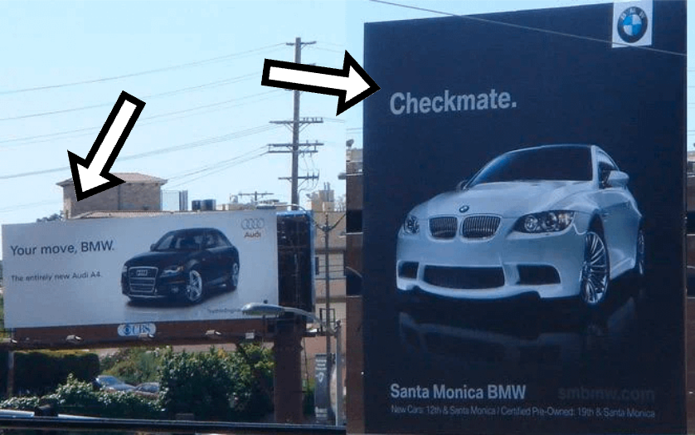

**Customer Journey Map**

|  | Awareness | Consideration | Purchase | Retention | Advocacy |
| --- | --- | --- | --- | --- | --- |
| Touchpoints | Online Research | Real life view and test the product | Financing options | Service and support | Word of mouth, posting UGC on social media (considering the experience was good - that’s now earned media for BMW) |
| Social media/TV ad engagement | Comparing other options | Customization | Experience in owning the car |
| Business actions | Publishing articles | Offering test drives | Providing financing options | Offering support after purchase | Engaging on social media when possible |
| Social media posts and TV ads | Providing pros against competitors | Offering customization | Offering maintenance services |
| Customer actions | Reading articles | Test driving | Discussing financing options | Driving the car and seeking maintenance when needed | Recommending the brand to friends and family |
| Viewing social media posts | Comparing features | Deciding on customizations |
| Emotions | Curiosity, first impression on the product | Interest and evaluation stage | Decision-making, clearing any doubts | Satisfaction and excitement | Satisfaction and loyalty |
|

The Marketing Channel worked and efficiency was the main benefit pushed on ads, after the customer bought the product, he got to know that it’s true and you can get a luxurious car that doesn’t need a VIP card in the petrol stations.